# **Digital Forensics Investigation Report**

**Rhinoceros Image Case – University of New Orleans**

## **1. Introduction**

This report presents the results of a digital forensic investigation conducted as part of a Digital Forensics project. In 2004, the City of New Orleans passed a law making possession of nine or more unique rhinoceros images a serious crime. The investigation began after the University of New Orleans network administrator reported that the RHINOVORE monitoring system detected suspicious rhino-related network traffic.

The evidence provided for this investigation included:

* One forensic image of a USB storage device (RHINOUSB.dd)
* Three network trace files (rhino.log, rhino2.log, rhino3.log)
* A computer seized from a university lab, which was missing its hard drive

The goal of this investigation was to recover rhino images and determine how they were obtained, stored, transferred, and concealed.

## **2. Methodology**

This investigation followed standard digital forensic procedures to ensure evidence integrity and accurate analysis. All work was performed on forensic copies of the evidence only.

### **2.1 Analysis Environment**

All analysis was conducted inside a virtual machine environment. The virtual machine was configured with no network access enabled to prevent contamination or accidental external communication. All evidence files were first downloaded to a separate USB drive and then copied into the virtual machine for analysis.

### **2.2 Evidence Integrity and Hash Verification**

Before analysis began, the integrity of all provided evidence files was verified using a command-line hashing tool to calculate sha256 hashes.

The calculated hashes matched the hashes provided with the evidence for the following files:

* rhino.log
* rhino2.log
* rhino3.log
* RHINOUSB.dd

### **2.3 USB Image Analysis Using Autopsy**

Autopsy was used to analyze the forensic image of the USB device.

**Purpose of Autopsy:**

* To examine the USB file system
* To recover deleted files
* To analyze unallocated space
* To identify document and image files

**Procedure:**

1. A new case was created in Autopsy.
2. The USB image (RHINOUSB.dd) was added as a data source.
3. The correct time zone was configured.
4. Ingest modules were enabled, including:
   1. File Type Identification
   2. Deleted File Recovery
   3. Hash Lookup
   4. Keyword Search
5. Both allocated and unallocated space were analyzed.

Using Autopsy, multiple files were recovered, including image files and a Microsoft Word document. Some files had been deleted but were recoverable because the USB device had been reformatted without secure wiping.

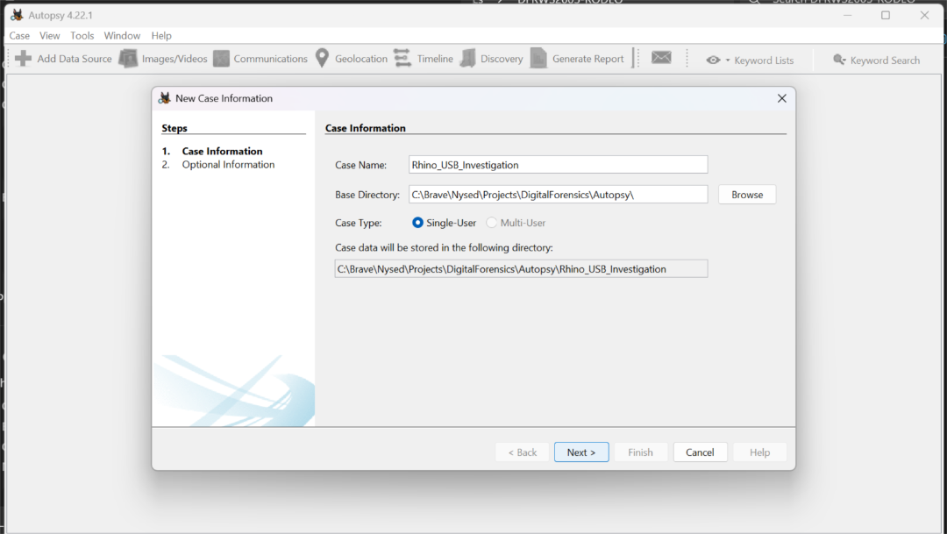

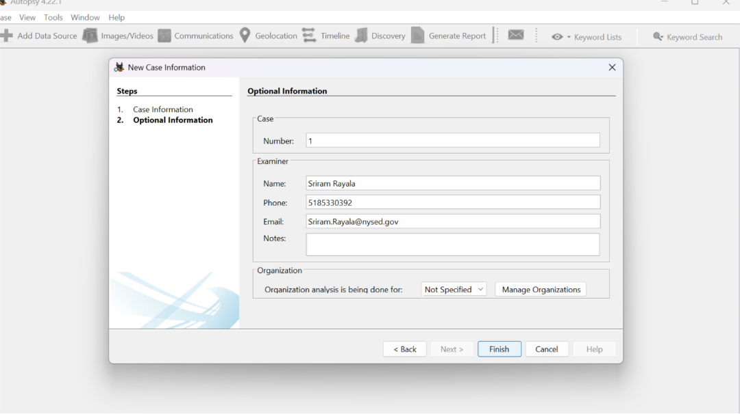

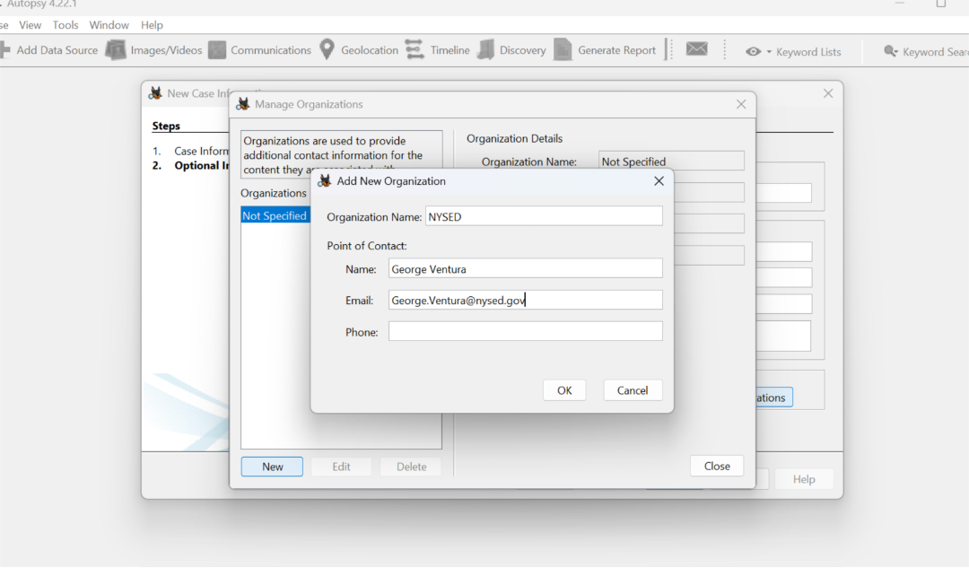

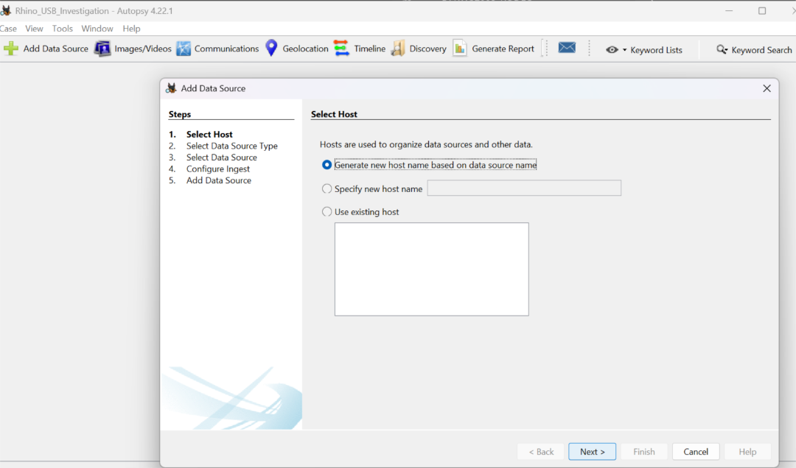

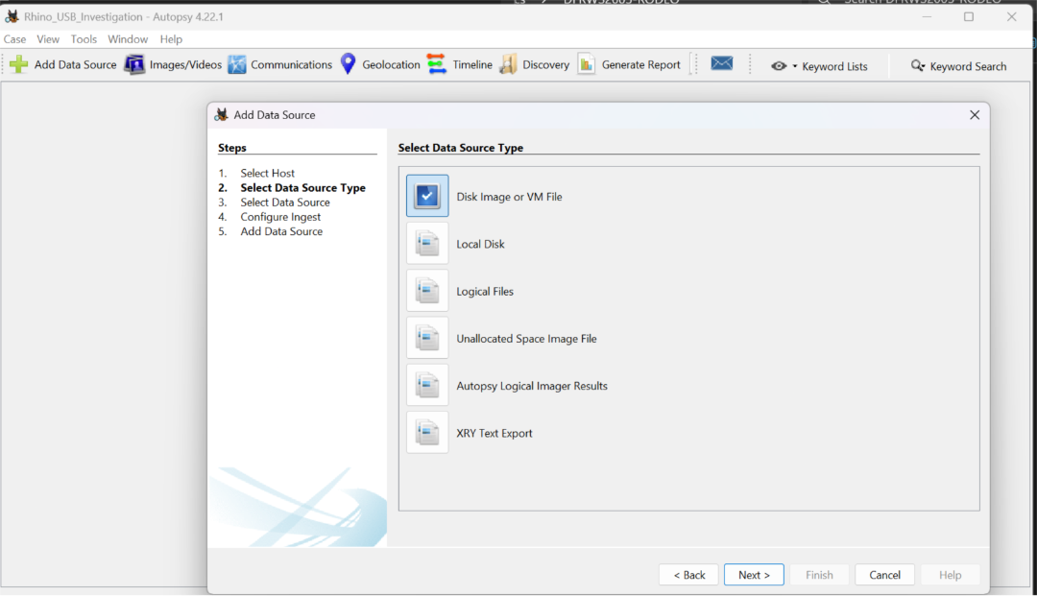

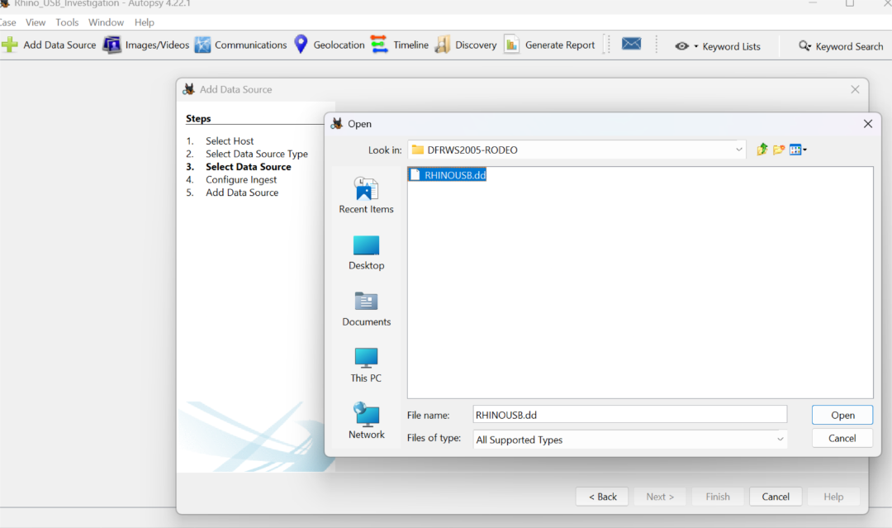

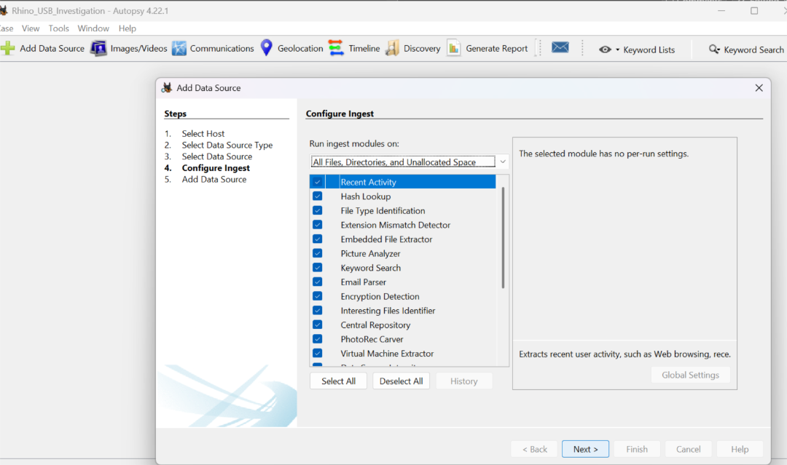

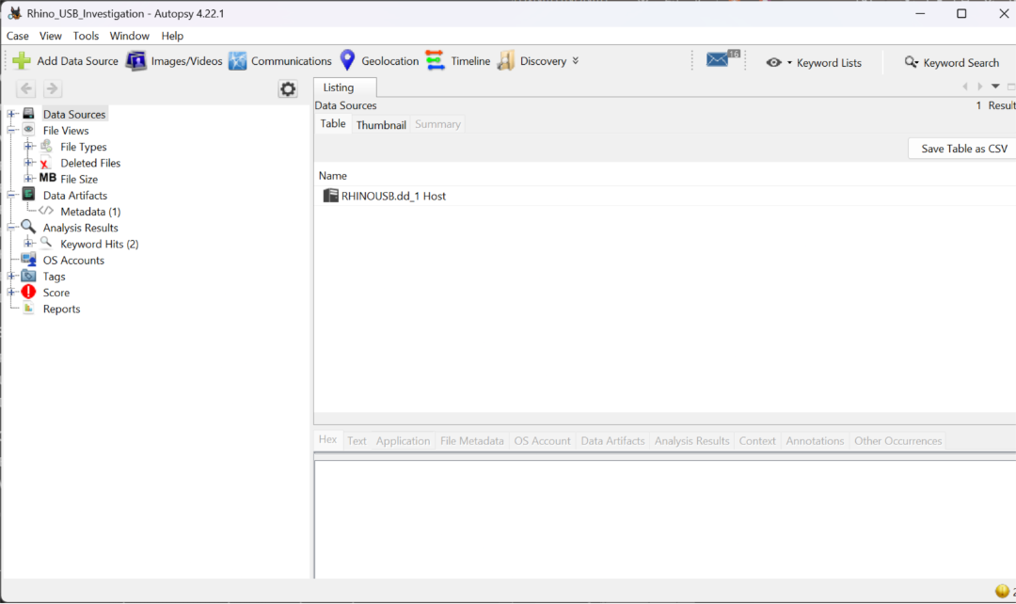

### **2.4 Network Trace Analysis Using Wireshark**

Wireshark was used to analyze the three provided network trace files.

**Purpose of Wireshark:**

* To examine network communication
* To identify file transfers
* To recover files transferred over the network
* To analyze plaintext authentication

**Procedure:**

1. Each network trace file (rhino.log, rhino2.log, rhino3.log) was opened individually.
2. Display filters were applied to isolate relevant protocols:
   1. HTTP
   2. FTP
   3. Telnet
3. The “Follow TCP Stream” feature was used to reconstruct sessions.
4. HTTP objects were exported where applicable.
5. FTP control and data channels were examined to identify uploaded files.

Recovered network files were compared with files recovered from the USB image to establish linkage between evidence sources.

## **3. Evidence Analysis and Findings**

### **3.1 USB Key Findings**

Analysis of the USB forensic image revealed:

* Four rhinoceros image files (JPEG/GIF formats)
* Several non-rhino animal image files
* One Microsoft Word document titled *“She died in February at the age of 74”*

The Word document contained detailed personal writing along with explicit statements about:

* Hiding rhino images
* Destroying the computer’s hard drive
* Reformatting the USB key
* Using a shared network account

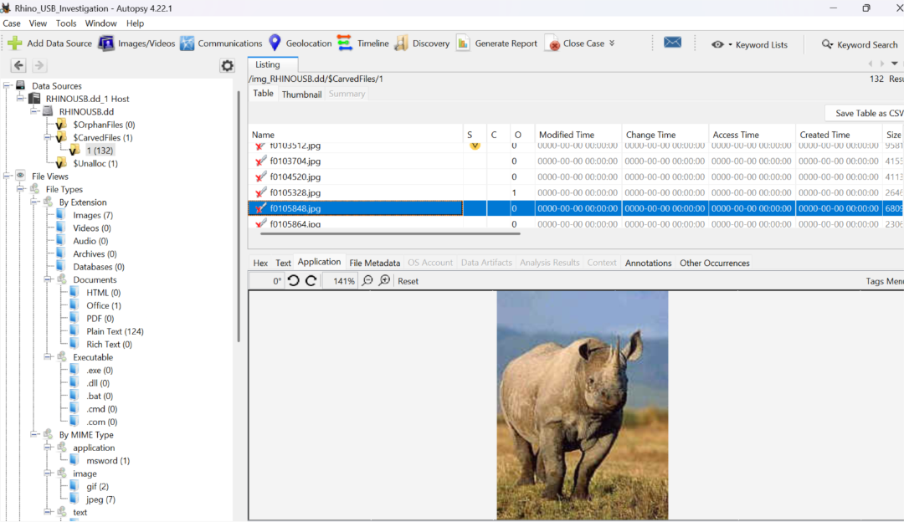

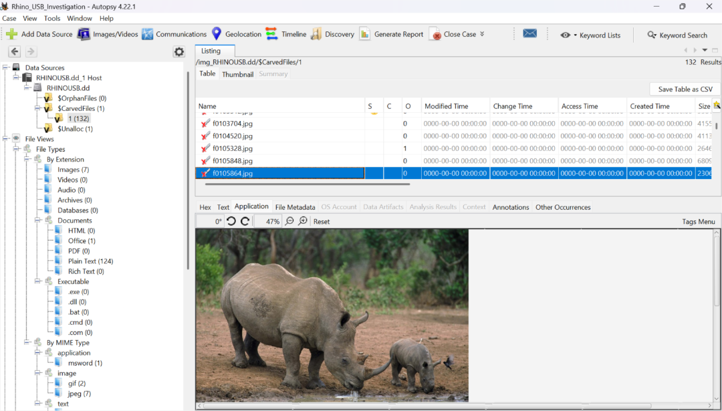

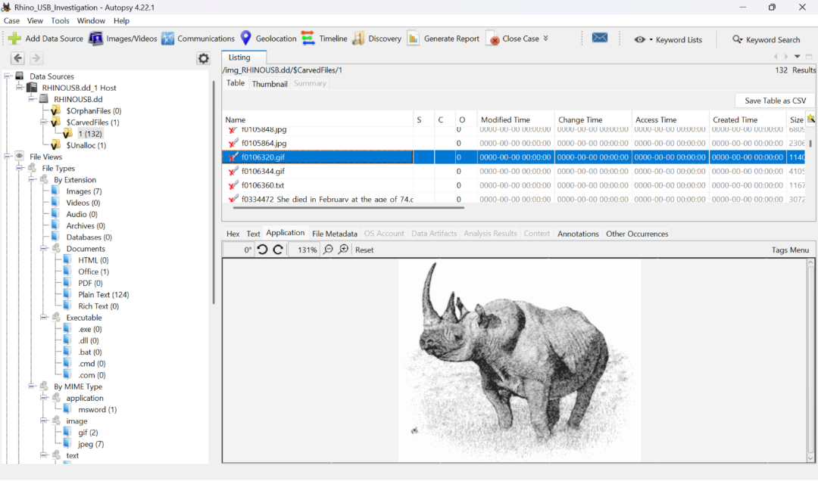

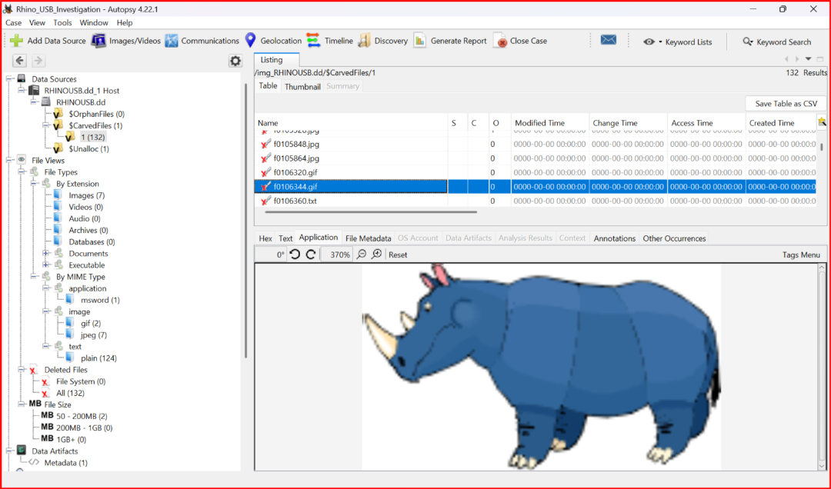

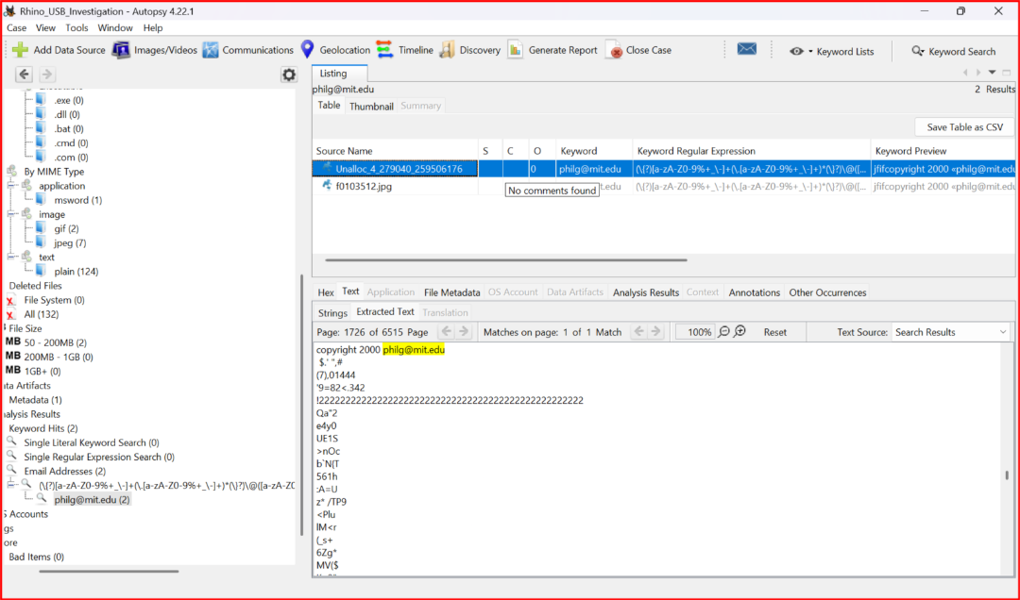

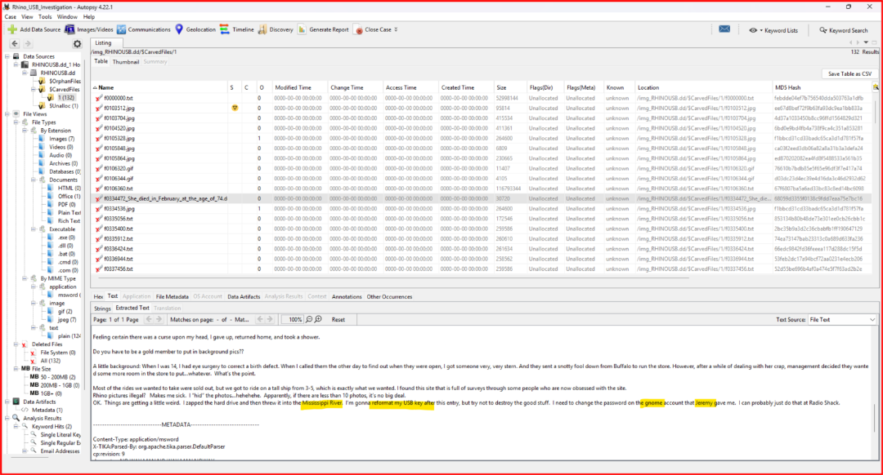

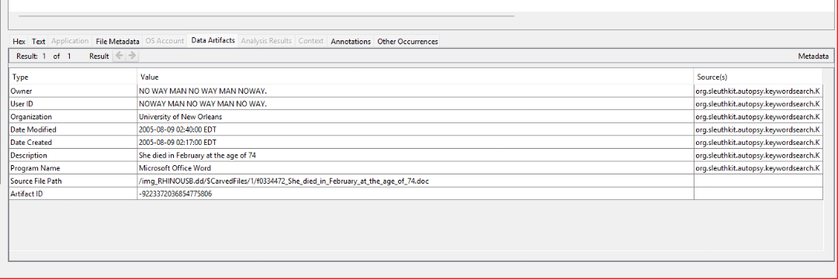

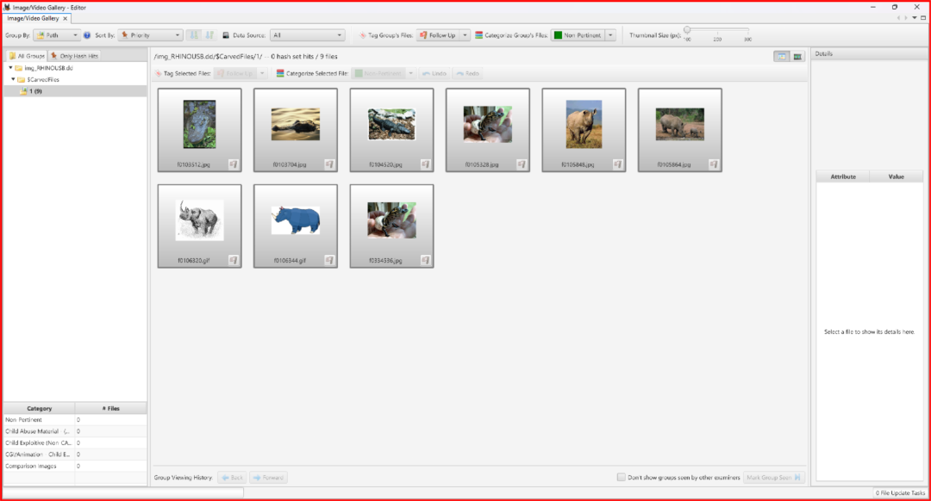

### **3.2 Network Trace Findings**

#### **rhino.log**

* Two unique rhino image files were recovered from network traffic
* FTP and HTTP activity involving the gnome account was observed
* A zip file was found with password protection

#### **rhino2.log**

* Two additional unique rhino image files were recovered
* HTTP object extraction confirmed image transfers

#### **rhino3.log**

* Contained supporting Telnet, FTP, and HTTP session data
* No additional unique rhino images were recovered

Additionally, HTTP traffic showed a download of a Windows executable file (rhino.exe) from a university web server.

1. Rhino.log pcap

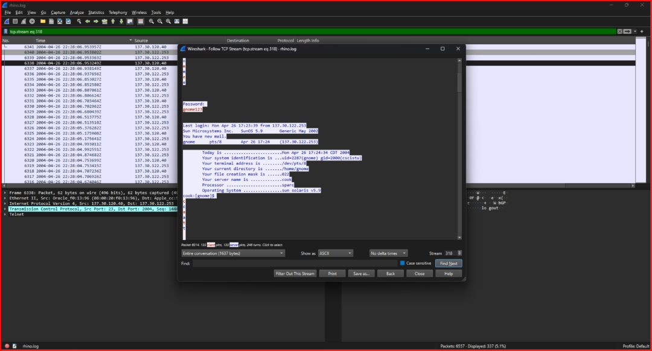

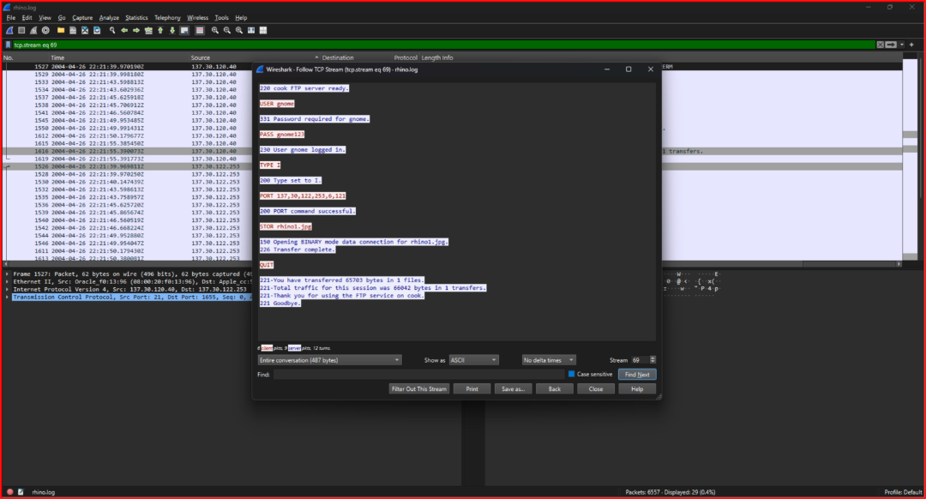

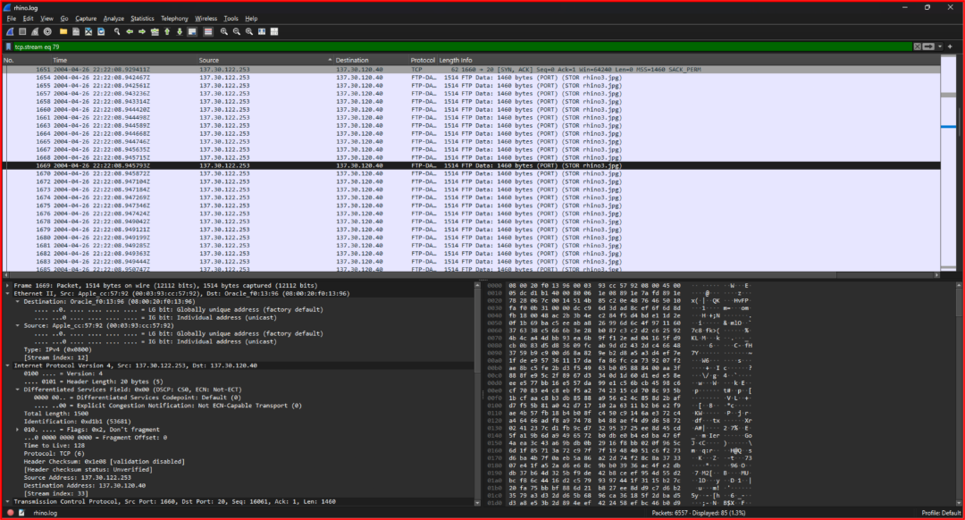

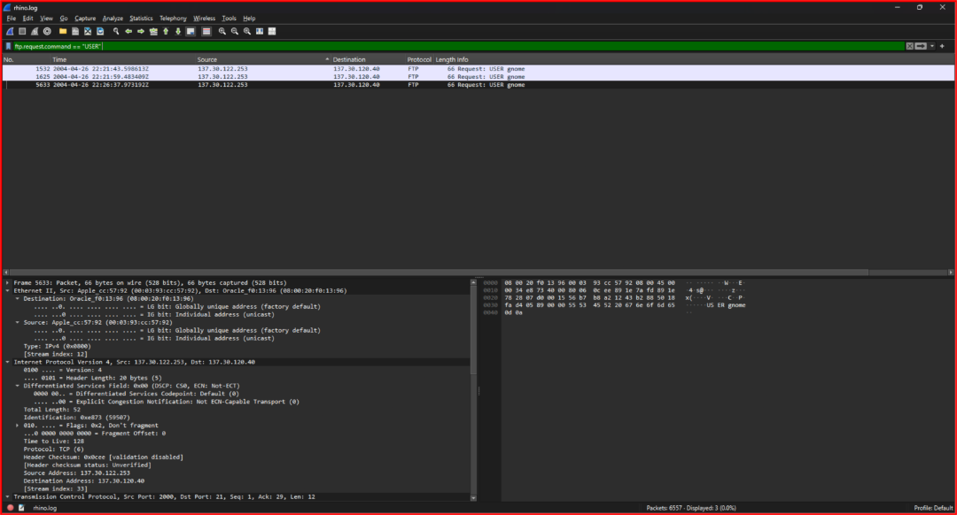

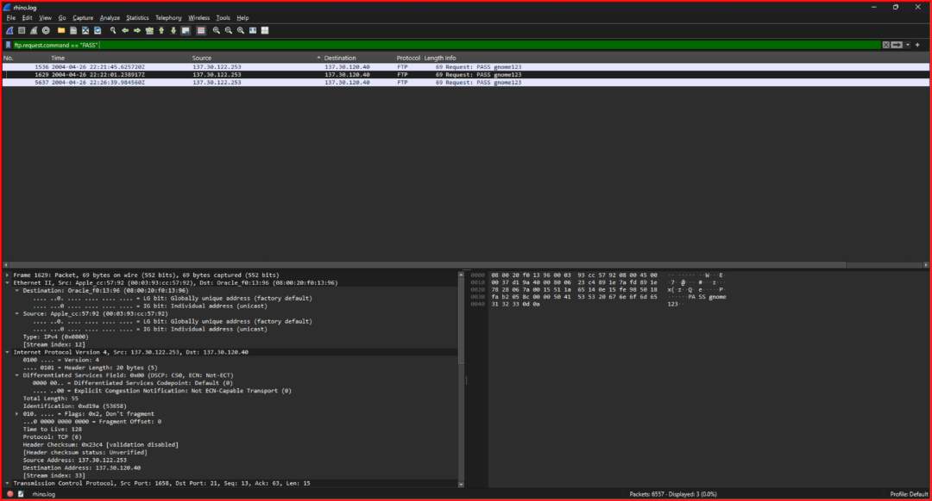

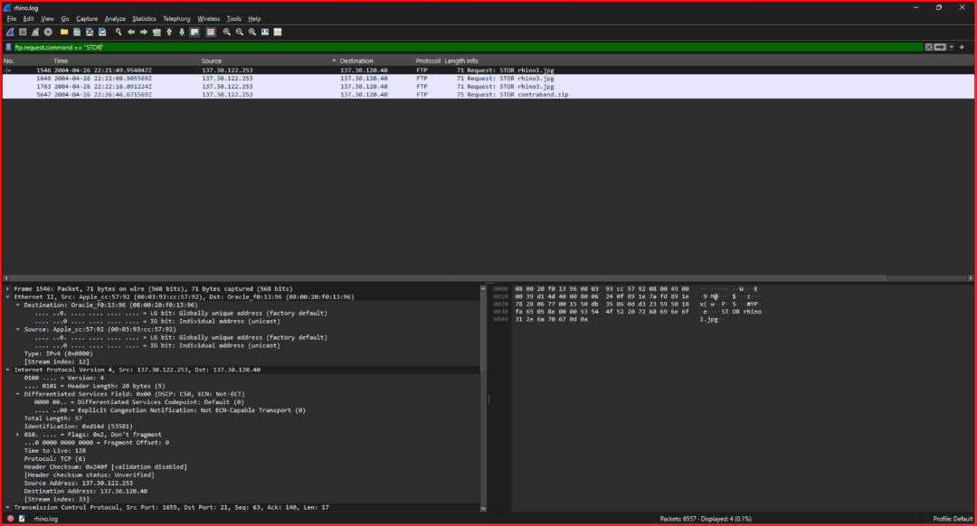

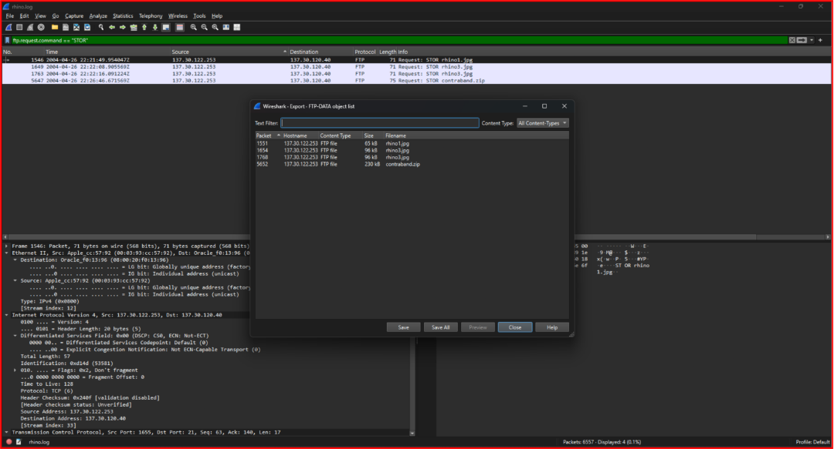

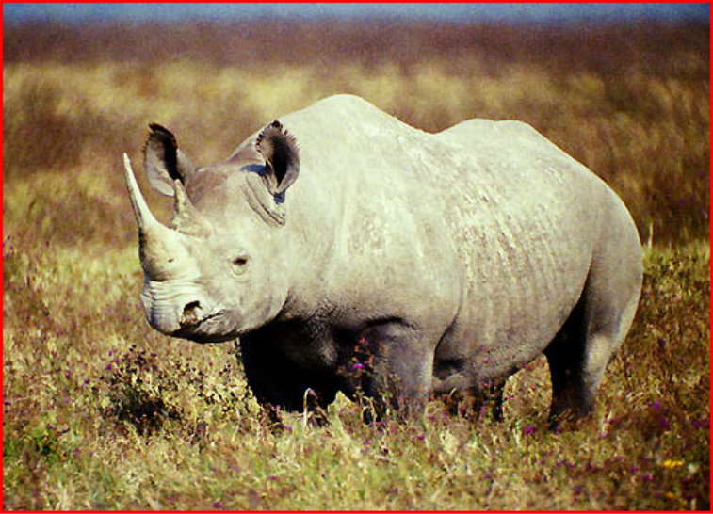

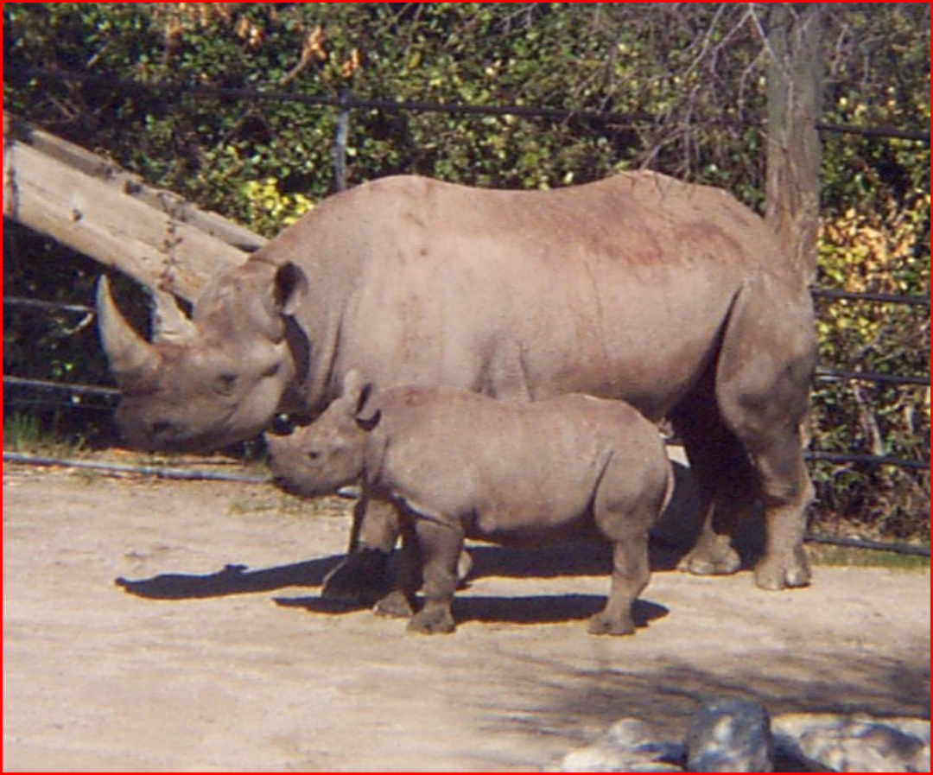

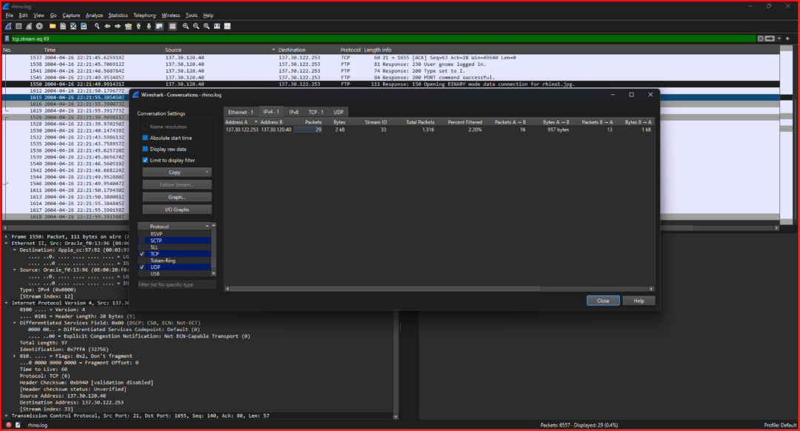

1. Rhino2.log

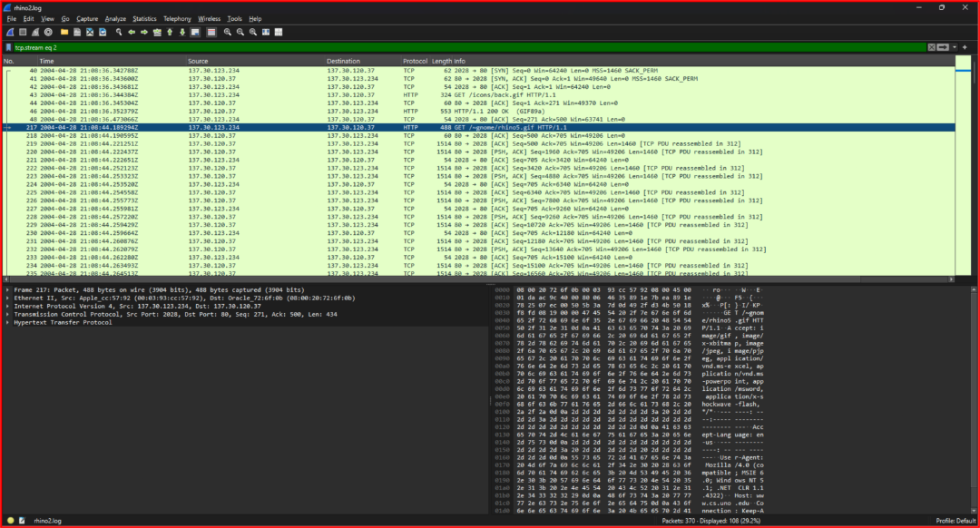

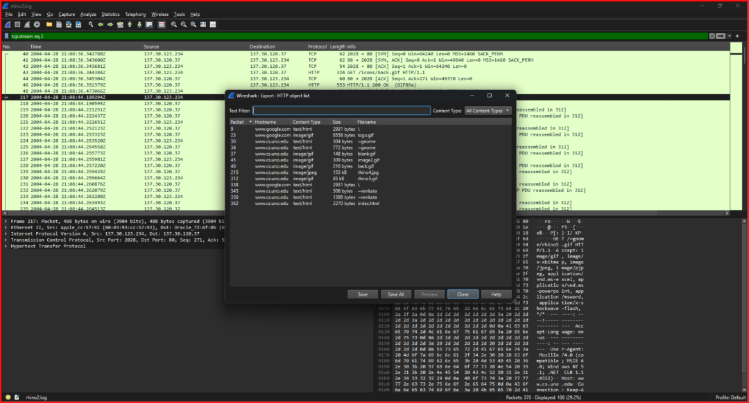

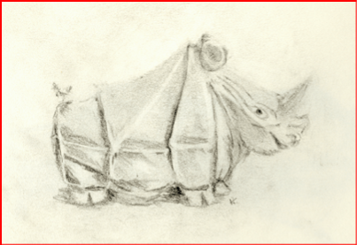

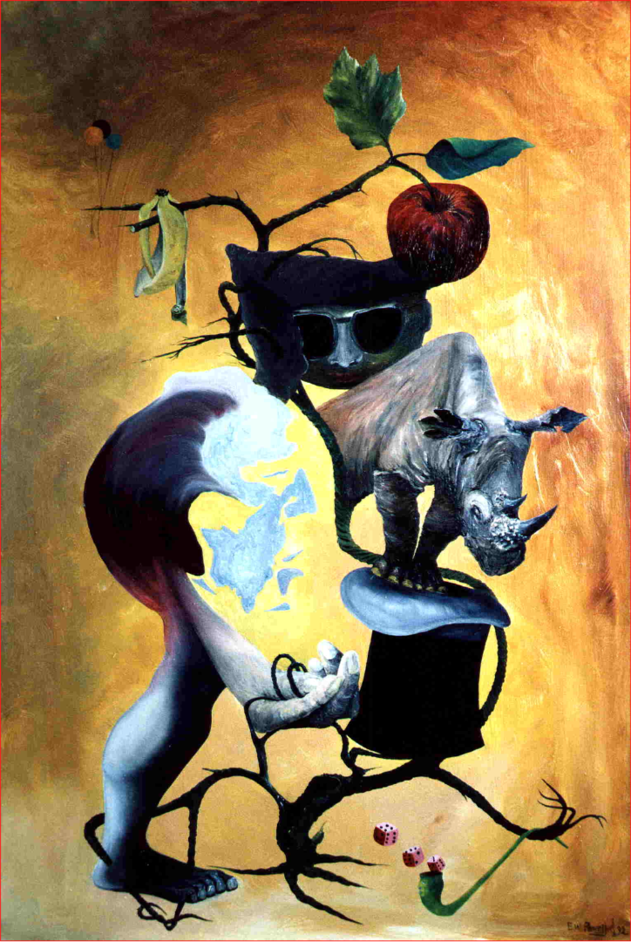

1. Rhino3

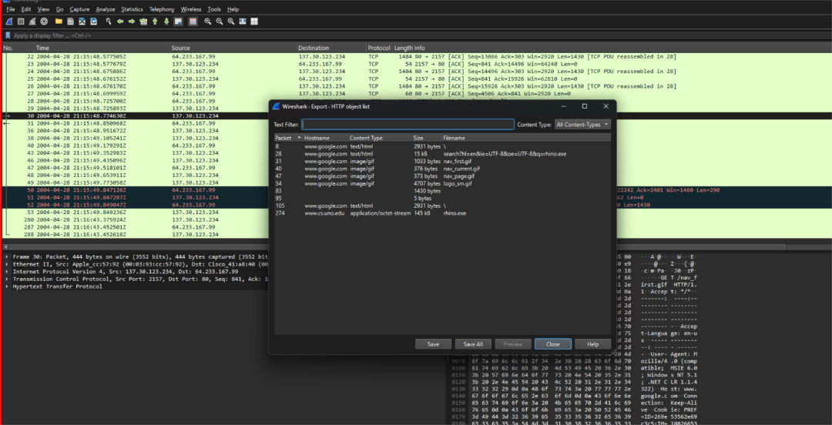

## **4. Answers to Investigation Questions**

### **4.1 Who gave the accused a telnet/ftp account?**

**Answer:**  
 The account was given by Jeremy.

**Evidence:**  
 The Word document states that the gnome account was provided by Jeremy.

### **4.2 What’s the username/password for the account?**

**Answer:**

* Username: gnome
* Password: gnome123

**Evidence:**  
 Plaintext credentials were observed in both FTP and Telnet sessions within the network traces.

### **4.3 What relevant file transfers appear in the network traces?**

**Answer:**

* HTTP download of rhino.exe
* FTP uploads of rhino image files to server cook
* HTTP access to rhino images in the gnome directory
* Two rhino images recovered from rhino.log
* Two rhino images recovered from rhino2.log

### **4.4 What happened to the hard drive in the computer? Where is it now?**

**Answer:**  
 The hard drive was intentionally destroyed and thrown into the Mississippi River.

**Evidence:**  
 This was explicitly stated in the recovered Word document.

### **4.5 What happened to the USB key?**

**Answer:**  
 The USB key was used to store rhino images and related files and was later reformatted in an attempt to remove evidence.

### **Evidence**

A Microsoft Word document recovered from the USB image (**RHINOUSB.dd**) explicitly states:

*“I’m gonna reformat my USB key after this entry, but try not to destroy the good stuff.”*

This statement directly demonstrates intentional alteration of the USB device to remove evidence, and it is confirmed by the recovery of deleted rhinoceros image files from unallocated space on the same USB device.

### **4.6 What is recoverable from the dd image of the USB key?**

**Answer:**

* Four rhinoceros images
* Several non-rhino animal images
* One Microsoft Word document containing admissions and explanations

Deleted data was recoverable due to improper wiping.

### **4.7 Is there any evidence that connects the USB key and the network traces?**

**Answer:**  
 Yes.

**Evidence includes:**

* Rhino images present in both USB and network data
* Use of the same gnome account across Telnet, FTP, HTTP, and mention in the Word document
* Written admissions explaining the actions taken

## **5. Reconstructed Timeline of Events (Detailed)**

1. **Account Access**
   1. Jeremy provides Telnet/FTP credentials (gnome) to the accused.
2. **System Use**
   1. The accused logs into a university lab computer using the provided account.
3. **Initial Download**
   1. rhino.exe is downloaded via HTTP from a university web server.
4. **Image Creation**
   1. The executable is run locally, producing rhino image files.
5. **Server Upload**
   1. Rhino images are uploaded to the server cook using FTP.
6. **Web Access**
   1. Some images are made accessible via the ~gnome web directory and accessed over HTTP.
7. **USB Storage**
   1. Rhino images and related files are copied to a USB storage device.
8. **Attempted Cover-Up**
   1. The computer’s hard drive is destroyed and discarded in the Mississippi River.
   2. The USB key is reformatted.
9. **Detection**
   1. RHINOVORE flags illegal rhino-related network traffic.
10. **Seizure and Analysis**
    1. The USB device and computer are seized.
    2. Forensic analysis recovers images and documents from the USB and network traces.

### **6. Additional Analysis and Hidden Content Examination**

As part of the investigation, a password-protected archive named **contraband.zip** was recovered from the **first network trace (rhino.log)**. The archive was not found on the USB key but was reconstructed directly from FTP traffic captured in the PCAP. The file was confirmed to be encrypted. To access its contents, the ZIP hash was generated using zip2john, and a dictionary-based password cracking attempt was performed using **John the Ripper** with the rockyou wordlist. The password **“monkey”** was successfully recovered. After extraction, the archive was found to contain **rhino2.jpg**. This image was already observed in a separate network trace, confirming that the same rhino image was transferred multiple times across different sessions. Although the image itself was not new, the use of password protection demonstrates an attempt to conceal illegal content during network transmission.

In addition, steganography analysis tools were applied to the recovered rhino images to determine whether hidden data was embedded within them. The tools **Stegdetect**, **Steghide**, and **JPSeek/JPHide** were used to analyze both USB-recovered images and images reconstructed from network traces. Stegdetect scans did not produce conclusive evidence of embedded steganographic payloads. Attempts to extract hidden content using Steghide with known passwords (including credentials observed in network traffic) were unsuccessful. JPSeek analysis also did not reveal hidden payloads within the JPEG files. Based on these results, no recoverable steganographic data was identified; however, the use of encryption on the ZIP archive itself indicates deliberate concealment techniques were employed even if image level steganography was not successfully used.

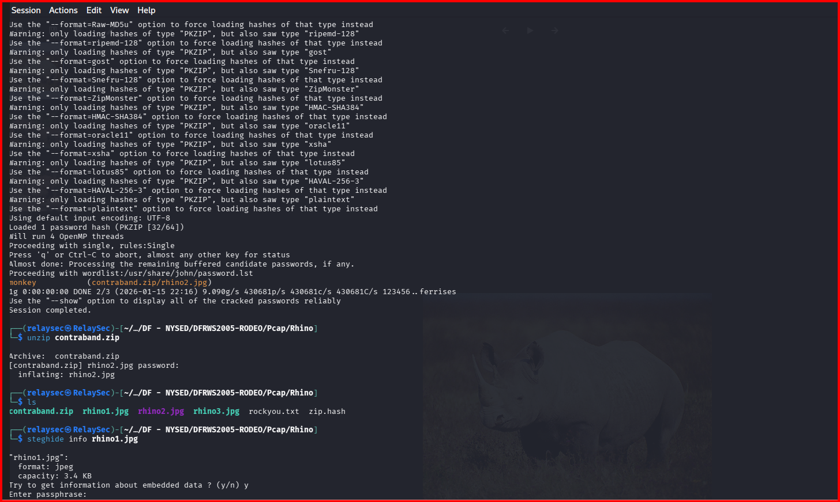

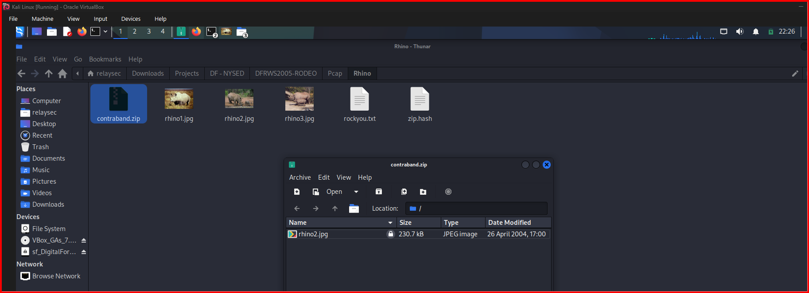

## **6. Conclusion**

This investigation demonstrates that the accused obtained rhinoceros images through network activity, transferred and staged them using a university server, and stored copies on a USB device. Attempts were made to conceal evidence by destroying the computer’s hard drive and reformatting the USB key. Despite these actions, forensic analysis of the USB image and network traces successfully recovered rhino images and a document containing direct admissions. The evidence clearly links the accused to the illegal possession and handling of rhinoceros images.